**Base image Prompt**  
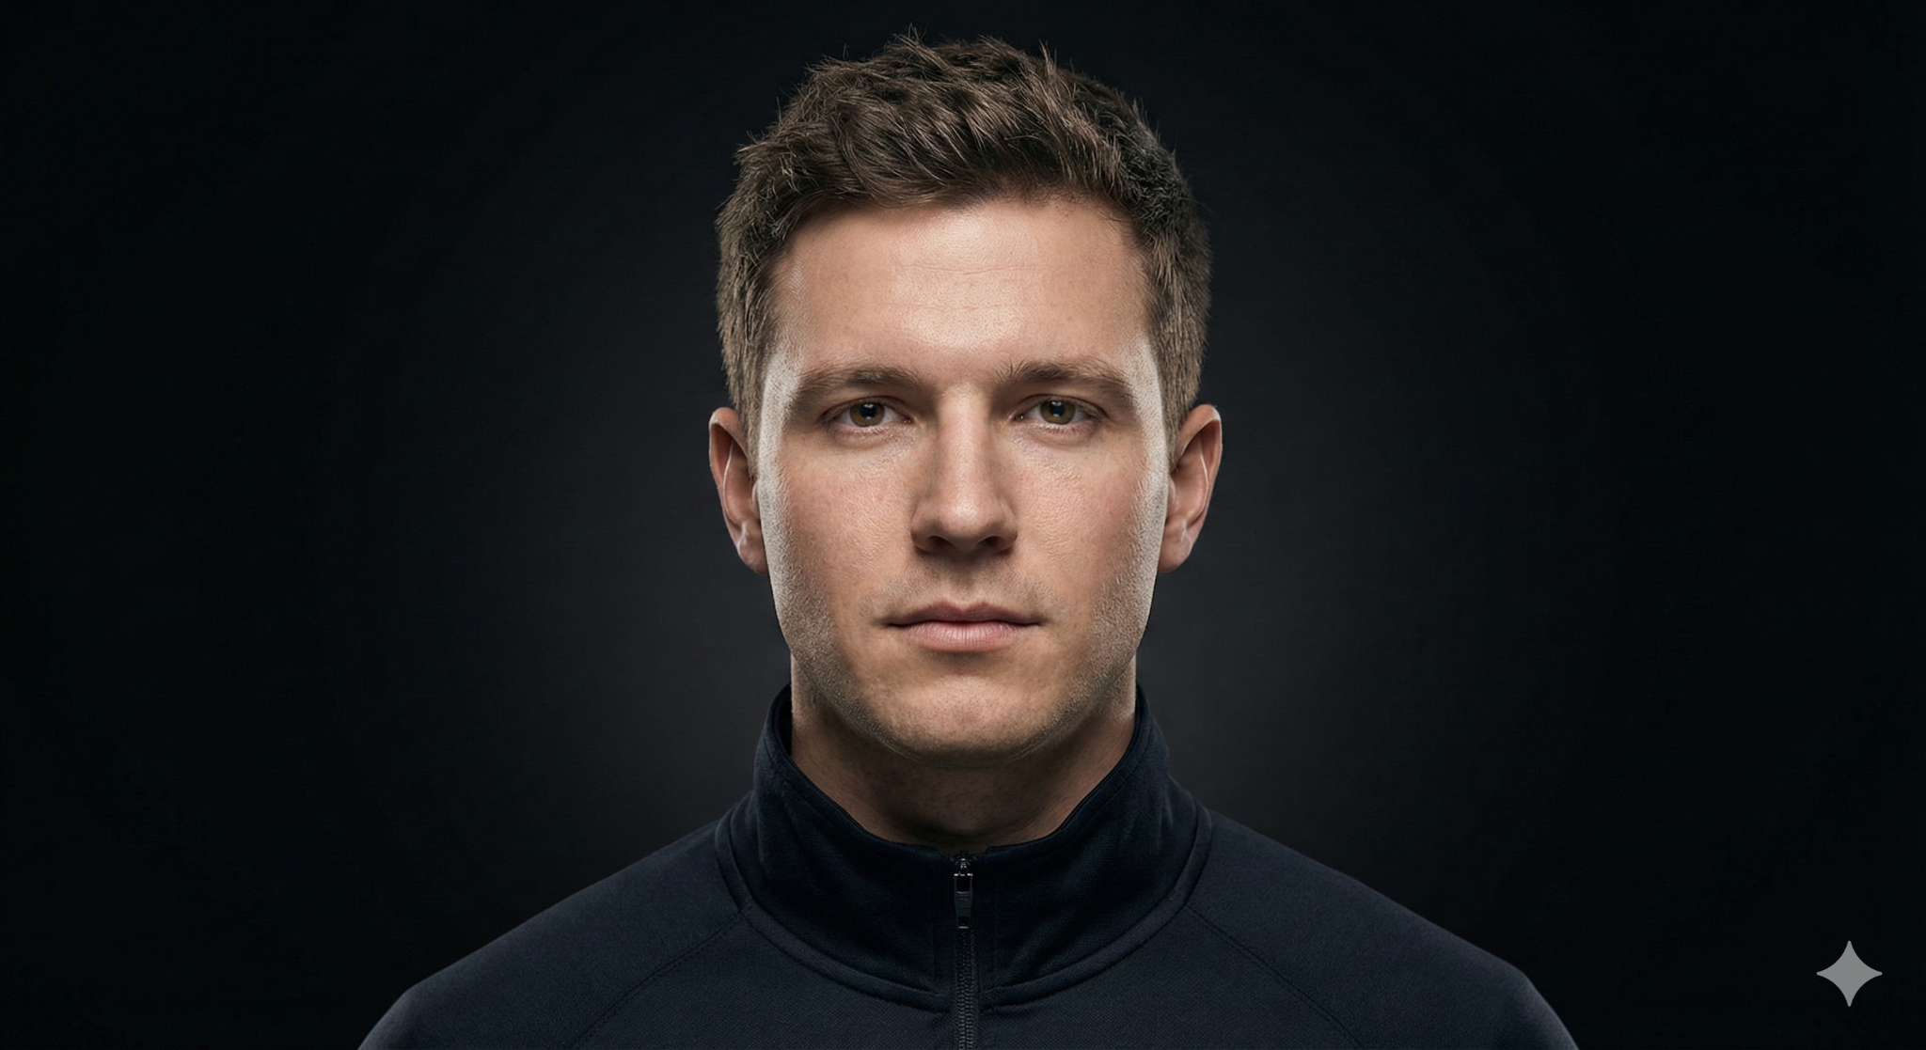  
  
- {

"type": "image_generation",

"style": "ultra-realistic studio portrait",

"subject": {

"gender": "male",

"age_range": "20-30",

"ethnicity": "american caucasian",

"expression": "neutral, confident, calm",

"pose": "front-facing, head and shoulders, perfectly centered",

"gaze": "direct eye contact with camera"

},

"composition": {

"framing": "tight close-up from top of head to upper chest",

"symmetry": "highly symmetrical facial alignment",

"depth_of_field": "shallow depth of field, face in sharp focus"

},

"lighting": {

"key_light": "soft frontal key light slightly above eye level",

"fill_light": "very subtle fill to preserve facial detail",

"rim_light": "minimal rim light for head separation",

"contrast": "high contrast with smooth shadow falloff",

"skin_detail": "natural skin texture, pores visible, no beauty smoothing"

},

"background": {

"color": "deep matte black",

"gradient": "subtle radial gradient behind head",

"noise": "clean, no grain, studio-controlled"

},

"wardrobe": {

"clothing": "dark zip-up jacket or high-collar top",

"texture": "minimal pattern, premium fabric",

"branding": "none"

},

"camera": {

"lens": "85mm prime",

"aperture": "f/1.8",

"sensor": "full-frame",

"perspective": "eye-level"

},

"rendering": {

"photorealism": "extreme realism, editorial quality",

"color_grading": "neutral cinematic tones",

"retouching": "professional but restrained, no artificial look"

},

"mood": "intense, premium, modern, minimal",

"negative_prompt": [

"cartoon",

"illustration",

"cgi",

"over-smoothing",

"plastic skin",

"dramatic colors",

"harsh shadows",

"visible logos",

"celebrity likeness"

]

}

**Overlay Image prompt**   
- Upload the first image as position and style reference while using this prompt  
  
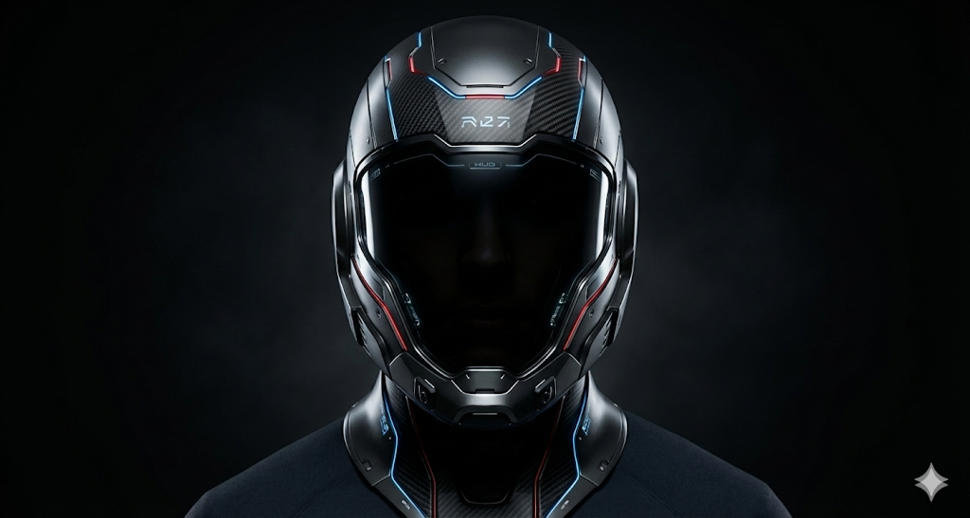  
  
{

"type": "image_generation",

"style": "ultra-realistic cinematic sci-fi portrait",

"base_image_usage": "use uploaded portrait only for head proportions and alignment",

"subject": {

"identity": "fictional male",

"pose": "front-facing, head and shoulders, centered",

"face_visibility": "fully concealed by helmet",

"emotion": "powerful, mysterious, elite"

},

"helmet": {

"coverage": "full-face enclosed helmet, no skin visible",

"concept": "high-end futuristic fantasy helmet",

"design_language": "advanced sci-fi with luxury craftsmanship",

"structure": "monolithic shell with segmented armor geometry",

"materials": [

"matte black titanium",

"dark chrome alloy",

"carbon fiber",

"energy-reactive glass"

],

"visor": {

"type": "opaque or semi-opaque visor",

"color": "deep black with subtle inner glow",

"visibility": "eyes NOT visible",

"effects": "faint internal HUD reflections only"

},

"details": [

"micro-panel seams",

"precision vents",

"etched futuristic symbols",

"thin glowing energy lines along contours",

"layered mechanical depth"

]

},

"integration": {

"helmet_fit": "perfect anatomical fit to head",

"edges": "seamless closure around neck and jaw",

"realism": "physically accurate proportions and reflections"

},

"lighting": {

"key_light": "soft frontal cinematic light",

"accent_lights": "controlled rim lights defining helmet silhouette",

"glow": "very subtle internal glow, not overpowering",

"contrast": "high contrast, smooth shadow gradients"

},

"background": {

"color": "deep matte black",

"style": "minimal futuristic atmosphere",

"effects": "subtle volumetric haze for depth"

},

"camera": {

"lens": "85mm prime",

"aperture": "f/1.8",

"perspective": "eye-level",

"depth_of_field": "shallow, helmet razor sharp"

},

"rendering": {

"photorealism": "extreme realism, AAA sci-fi film quality",

"textures": "ultra-detailed metal, glass, nano-surfaces",

"color_grading": "dark neutral cinematic tones",

"post_processing": "clean, premium, no stylized effects"

},

"mood": "mysterious, intimidating, futuristic, premium",

"negative_prompt": [

"face visible",

"eyes visible",

"open helmet",

"cartoon",

"anime",

"illustration",

"cgi look",

"cheap armor",

"bulky proportions",

"logos",

"text",

"celebrity likeness"

]

}